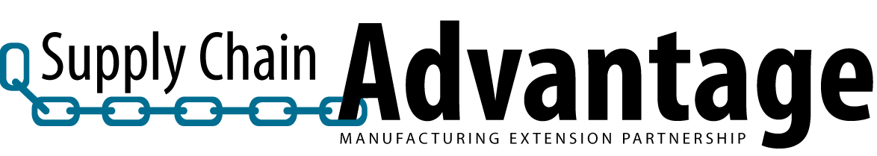

Accelerate MEP Post Phase I Project Review Questionnaire

M.E.P.: Supplier: Project Dates:
MEP Project Lead: Email:
MEP Project 2nd: Email:

Following the Accelerate Phase I project, the Supply Chain Advantage office requests that the MEP delivery staff complete the following questionnaire. The answers given are MEP confidential for Accelerate program assessment and management purposes only.

1) How would you assess the Suppliers attitude towards lean implementations?
Comments:
2) How would you assess the lean improvement opportunities that exist overall at this Supplier?
Comments:
3) How likely is the Supplier to apply these lean tools and strategies to other areas their business?
Comments:
4) How likely is this Supplier to contract with your MEP for future work?
Comments:
5) How would you assess the contribution of this Accelerate engagement towards the Supplier’s progress in understanding and implementing lean methodologies in their business?
Comments:
6) How would you asses the benefit of this Accelerate project in your Local MEP establishing/developing a relationship with this Supplier customer?
Comments:

